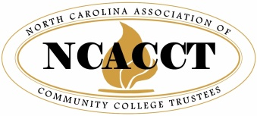
DRAFT
DRAFT

NCACCT 2021 VIRTUAL LEADERSHIP SEMINAR–AGENDA
Friday, April 23, 2021

9:00 – 10:15 a.m. | New Trustee Orientation  led by Tanya Evans, Board Chair at Piedmont Community College and District Manager with Duke Energy  If you need to complete the requirement for New Trustee Training, you must attend this Orientation AND the General Session.
10:15 – 11:15 a.m. | General Legislative Session  Featuring new NC Community College System President Thomas Stith and State Legislative Leaders, including Senate President Pro Tem Phil Berger and Speaker of the House Tim Moore.  If you need to complete the requirement for either New Trustee Training or Reappointed Trustee Training, you must attend this General Session.
11:15 – 11:30 a.m. | Break
11:30 a.m. –  12:30 p.m. | Legal Updates for Community Colleges  Speaker: Mr. Robert Joyce, Professor of Public Law and Government at UNC School of Government  If you need to complete the requirement for Reappointed Trustee Training, you must attend this Legal Updates session AND the General Session.
12:30 – 12:45 p.m. | Break
12:45 –  2:15 p.m. | Ethics Training  Presenter: David Smyth, Attorney, NC Ethics Commission
2:15 p.m. | Seminar Concludes

